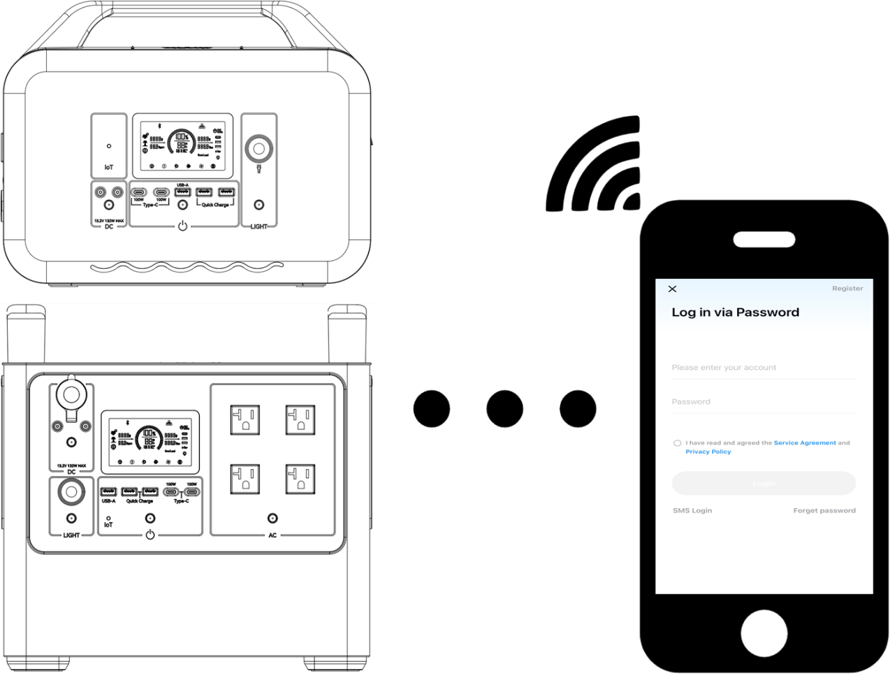

**Portable Power Station App**

**User Manual V3.0**

**CATALOGUE**

1 Disclaimer 1

2 Installation, Registration and Login 2

2.1 APP Installation 2

2.2 APP Registration and Login 3

3 Connection, Configuration and Usage 4

3.1 APP Connected Device 4

3.2 Device Controls and Main Functions 7

3.3 Other Functions Of The Device 9

3.4 Share Device/Delete Device 10

4 Intelligent Control Device 12

4.1 Scene Setting and Execution 12

4.2 Automation Control 14

4.3 Batch Control 17

5 System Setup 19

**1 Disclaimer**

■ Before using this product, please read this user manual carefully to ensure that you fully understand the product and can use it correctly. After reading this user manual, please keep it in a safe place for future reference. Improper use of this product may cause serious injury to yourself or others, or result in product damage and property loss. By using this product, you are deemed to have understood, recognised and accepted all the terms and contents of this document.

■ All terms and contents in the document. We are not responsible for any loss caused by the user's failure to use the product in accordance with this user manual.

■ In compliance with laws and regulations, we reserve the right of final interpretation of this document and all documents related to this product.

■ This document is subject to change (update, revision or termination) without notice. Please visit our official website for the latest product information.

**2 Installation, Registration and Login**

**2.1 APP Installation**

To enhance user experience, the APP is divided into two categories based on server location. Users can select the appropriate one according to their geographical area:

United States/Canada: **Landbook**

Other regions: **Wonderfree**

Hereinafter, both are collectively referred to as the " APP ".



**IOS Users:** Open the App Store, search for the corresponding APP (search

" **Landbook** " for the United States/Canada or " **Wonderfree** " for other regions), download and install the APP, and then open it to access the login interface.

**Android Users:** Open the Google Play Store, search for the corresponding APP (search " **Landbook** " for the United States or " **Wonderfree** " for other regions), download and install the APP, and then open it to access the login interface.

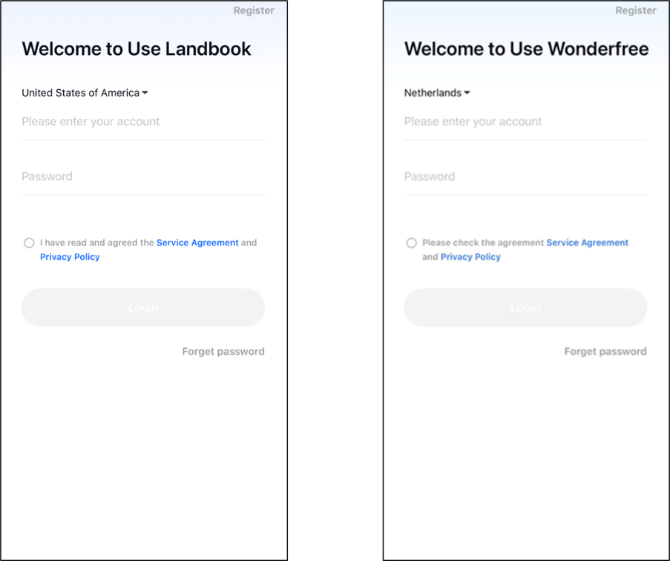

**2.2 APP Registration and Login**

**①** The first time you login to the APP, you need to register by email, click

" **Register** " in the upper right corner to start registration.

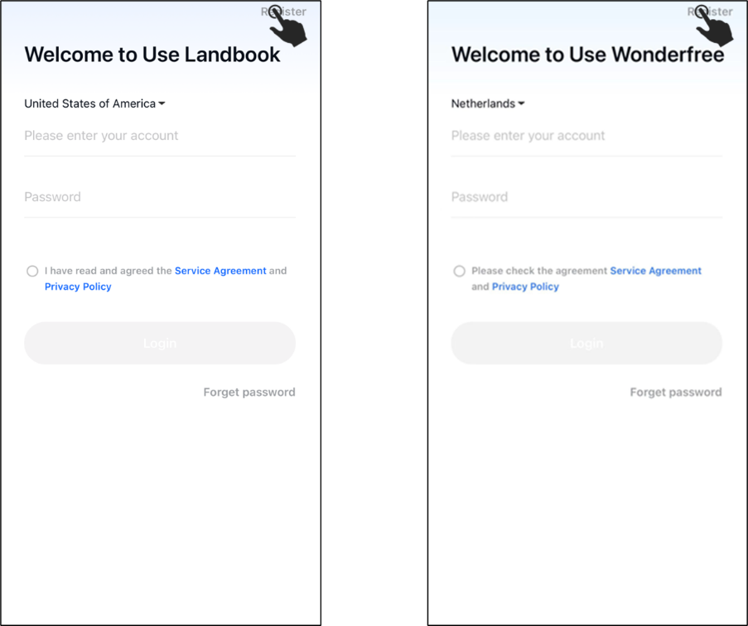

**②** Select the appropriate country or region, enter your email, fill in the code received in your email, and set a password to complete the registration. After registration, the chosen country during login should match the one during registration. Upon successful login, the APP displays the device list interface.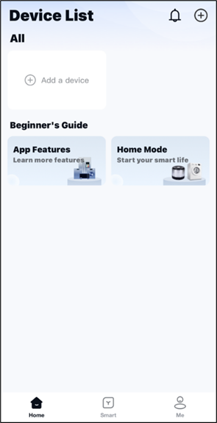

**3 Connection, Configuration and Usage**

**3.1 APP Connected Device**

During use, the APP requires Bluetooth and WIFI, please make sure that your mobile phone's Bluetooth and WIFI are turned on, and allow APP to access your location information during use.

**①** When the power station is powered on, use a needle to press the " **IOT** " hole on the power station panel until you hear a " **Beep** ". At this point, the network configuration icon on the LCD screen will start to blink.

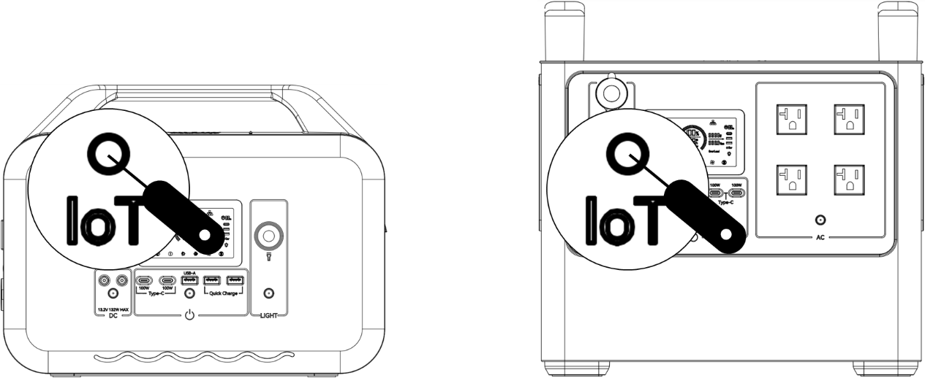

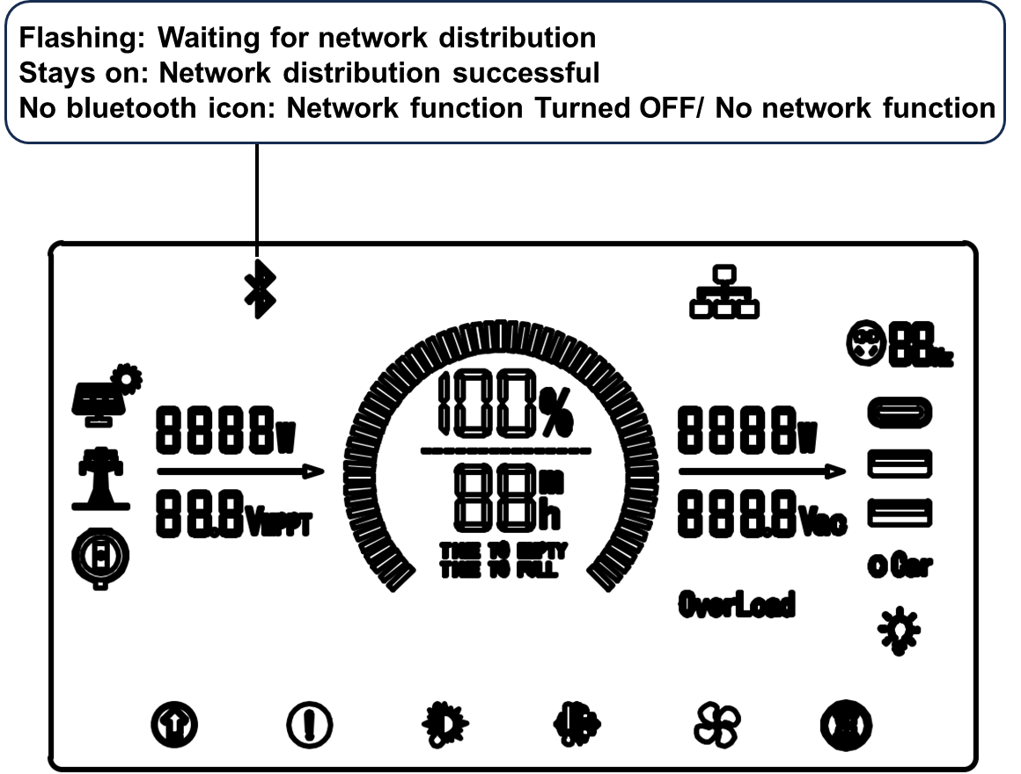

**②** Click on "" in the upper right corner of the page and select " **Detect Nearby Devices**". The app will display nearby addable devices.

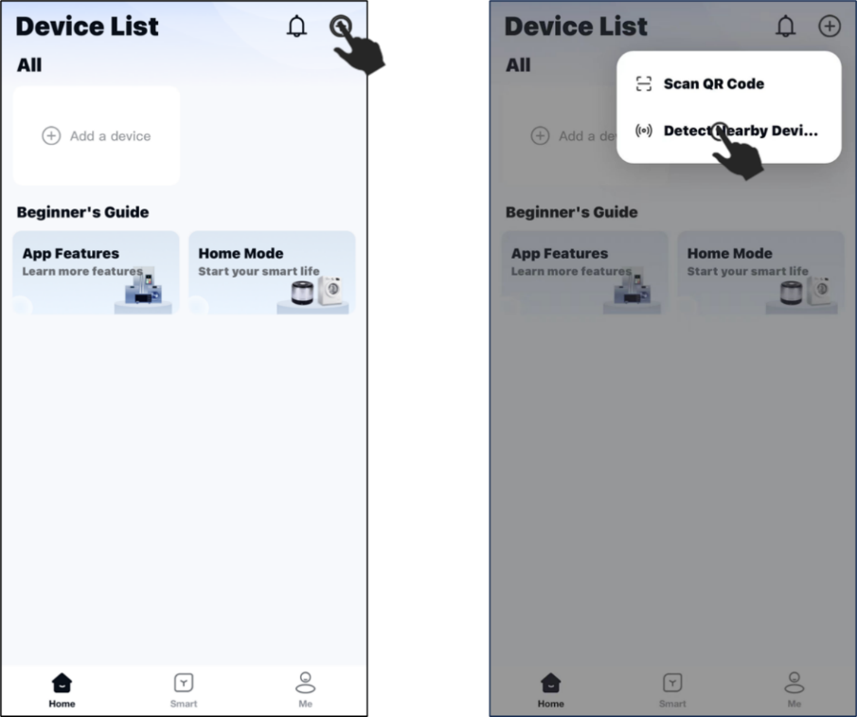

**③** Click on the "" button. Enter the WiFi account and password that you want the portable power station to connect to, and then select " **Next** " and wait for the progress bar to complete loading.

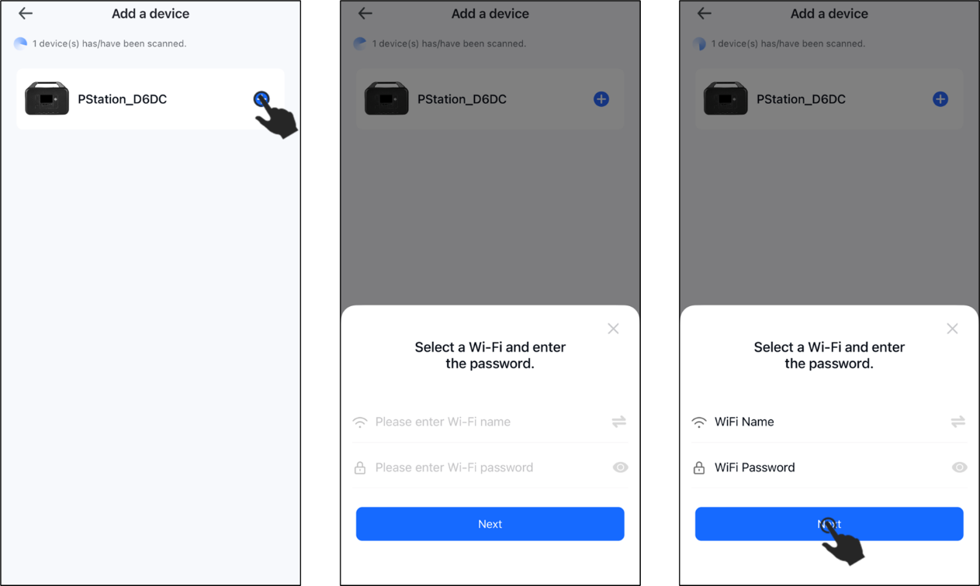

**④** After successful configuration, the interface will display the product devices. Click " **Done** ", then click " **Save**" to return to the device list. Users can also click "" to customise the device name, and then click " **Save** " to return to the device list.

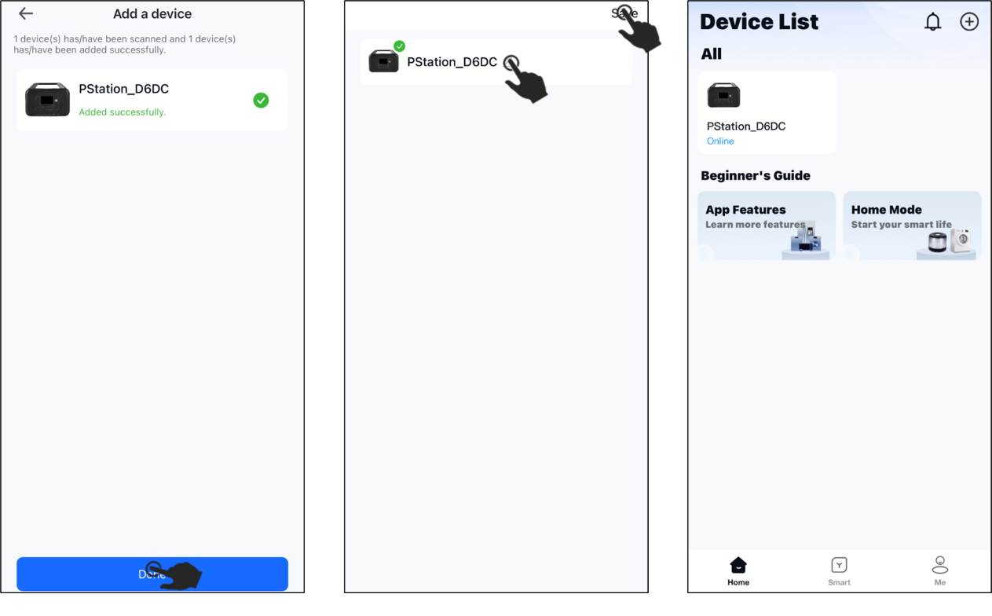

**NOTE**

■ If the APP cannot find the device for a long time, or the connection fails (shows timeout), repeat the above steps.

■ If you fail repeatedly, please contact the official customer service for technical support.

■ After successfully configuring the APP with the portable power station, please note the following:

**①** When the portable power station is turned off and restarted, there is no need to reconfigure. Just open the APP and wait for a while for the device to come online again.

**②** The network configuration icon on the power station's LCD screen reflects the connection status between the APP and the device. Blinking means waiting for a connection, while a constant light means it is connected (due to real-world factors like network conditions, there may be a delay between the status displayed in the APP and the power station's LCD screen. Waiting for some time or restarting the APP can resolve this).

**3.2 Device Controls and Main Functions**

Click the icon of the successfully connected device to enter the device control interface.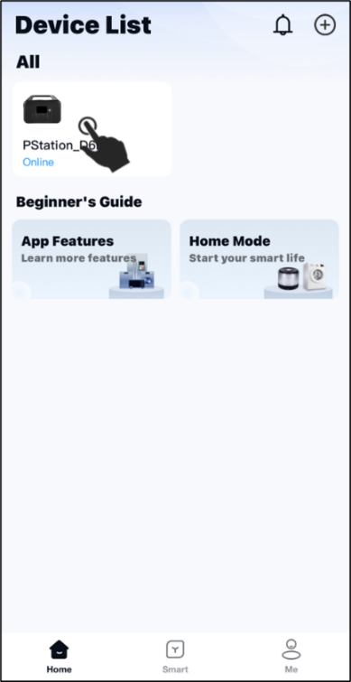

You can view the following Input/Output parameters and control the device after entering the device control interface.

**Input Parameters Panel:**

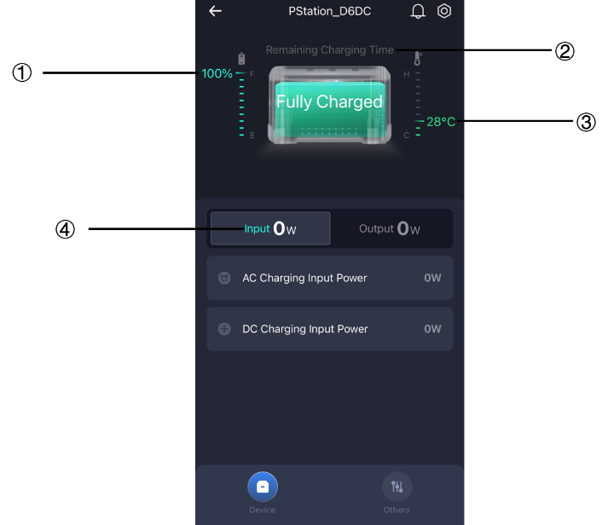

|  |  |  |
| --- | --- | --- |
| ① | **Remaining Power** | Percentage of device battery power remaining. |
| ② | **Remaining Availiable Time** | The theoretyical time the power station can be uesd with the remaining battery at the current output power. |
| ③ | **Battery Temperature** | The temperature of the Battery. |
| ④ | **Input Power** | Total battery charging power, including AC charging power and DC charging power. |

**Output Control Panel:**

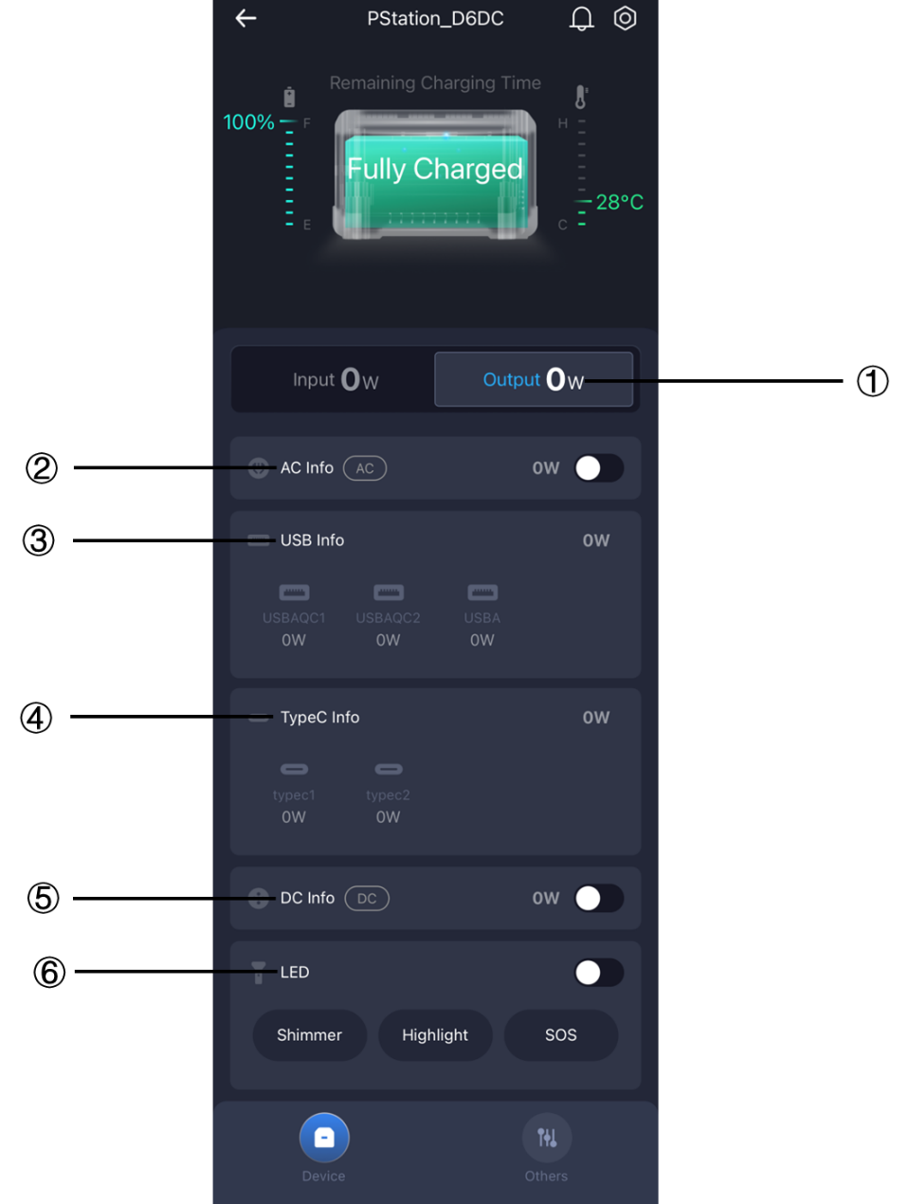

|  |  |  |
| --- | --- | --- |
| ① | **Output Power** | The total power discharged by the battery to external devices, including four types of power: AC, DC, USB, Type-C. |
| ② | **AC Info** | AC output switch to display AC output power. |
| ③ | **DC Info** | DC output switch to display DC output power. |
| ④ | **USB Info** | Displays the output power of the USB port. |
| ⑤ | **Type-C Info** | Displays the output power of the Type-C connector. |
| ⑥ | **LED** | LED light switch (Three modes: Shimmer/Highlight/SOS). |

**3.3 Other Functions Of The Device**

Click " **Other** " at the bottom of the panel to enter the auxiliary function

interface, which displays the following parameters/functions.

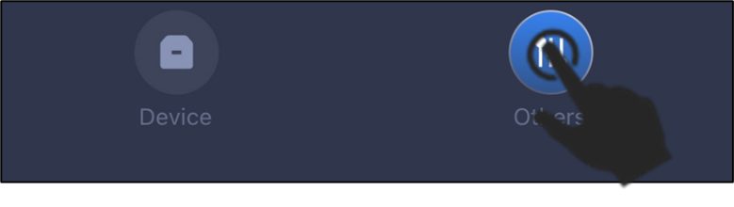

**Accessibility Control Panel:**

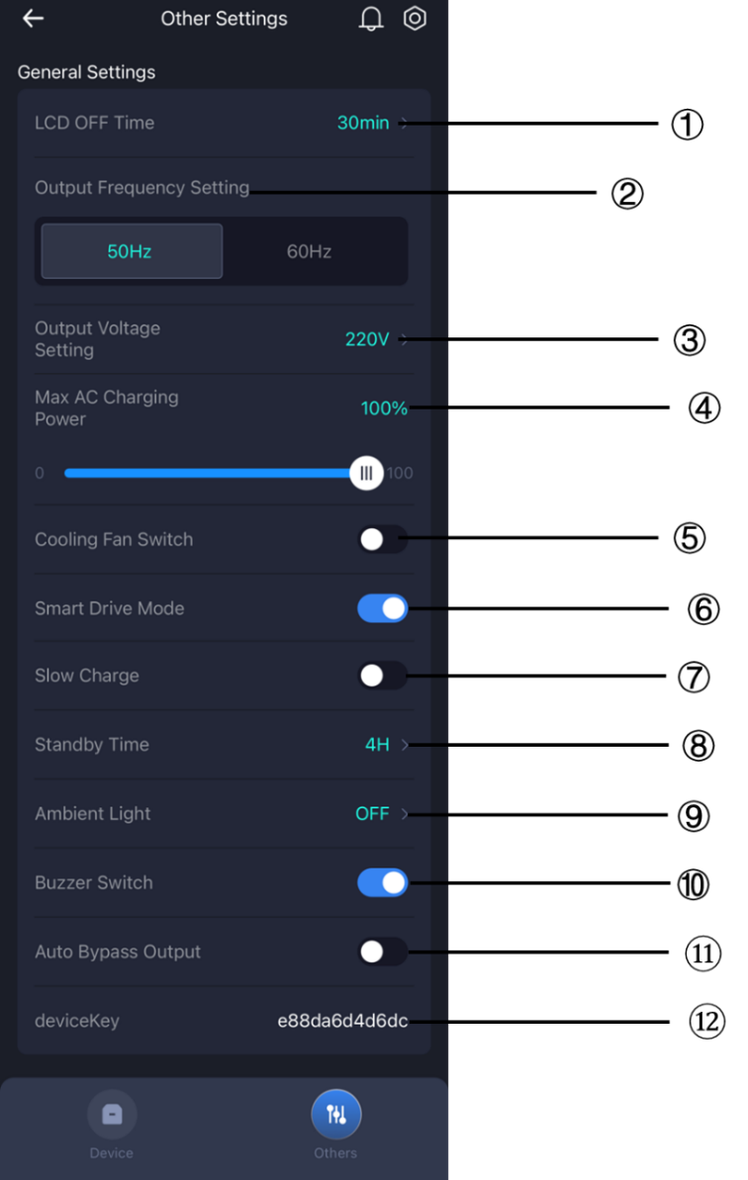

|  |  |  |
| --- | --- | --- |
| ① | **LCD OFF Time** | Setting the device rest time (0~24 hours). |
| ② | **Output Frequency**  **Setting** | 50~60HZ frequency automatic switching. |
| ③ | **Output Voltage**  **Setting** | 110V equipment voltage level:  100V/110V/120V.  220V equipment voltage level: 220V/230V/240V. |
| ④ | **Max AC Charging**  **Power** | Setting the upper limit of AC charging power (0~100%). |
| ⑤ | **Cooling Fan Switch** | Turn on/off fan. |
| ⑥ | **Smart Drive Mode** | Turn on/off constant power mode. |
| ⑦ | **Slow Charge** | Turn on/off slow charging. |
| ⑧ | **Standby Time** | Setting the device standby time. |
| ⑨ | **Ambient Light** | Turn on/off ambient light or selecting ambient light mode. |
| ⑩ | **Buzzer Switch** | Turn on/off device operation “ beep ”. |
| ⑪ | **Auto Bypass Output** | Turn on/off bypass mode. |
| ⑫ | **Device Key** | Device DK Code. |

**3.4 Share Device/Delete Device**

**①** After your mobile phone is successfully connected to the device, you can share the device with other mobile phone users. Long press on the device icon and click Share "" to display the device sharing QR code.

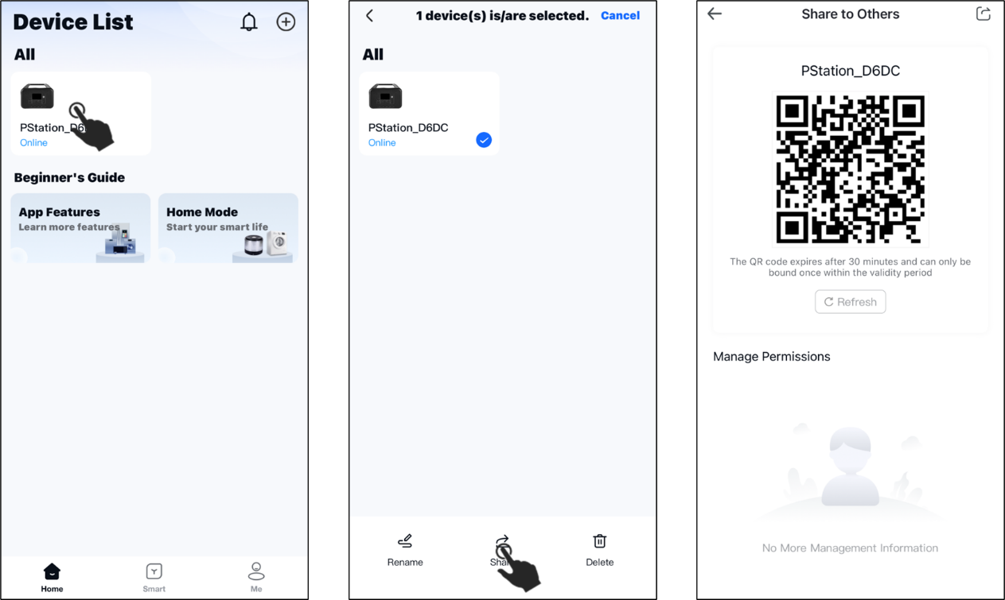

**②** Other users can add devices by scanning the device sharing QR code. Click "" in the top right corner of the interface and select "**Scan QR Code** ".

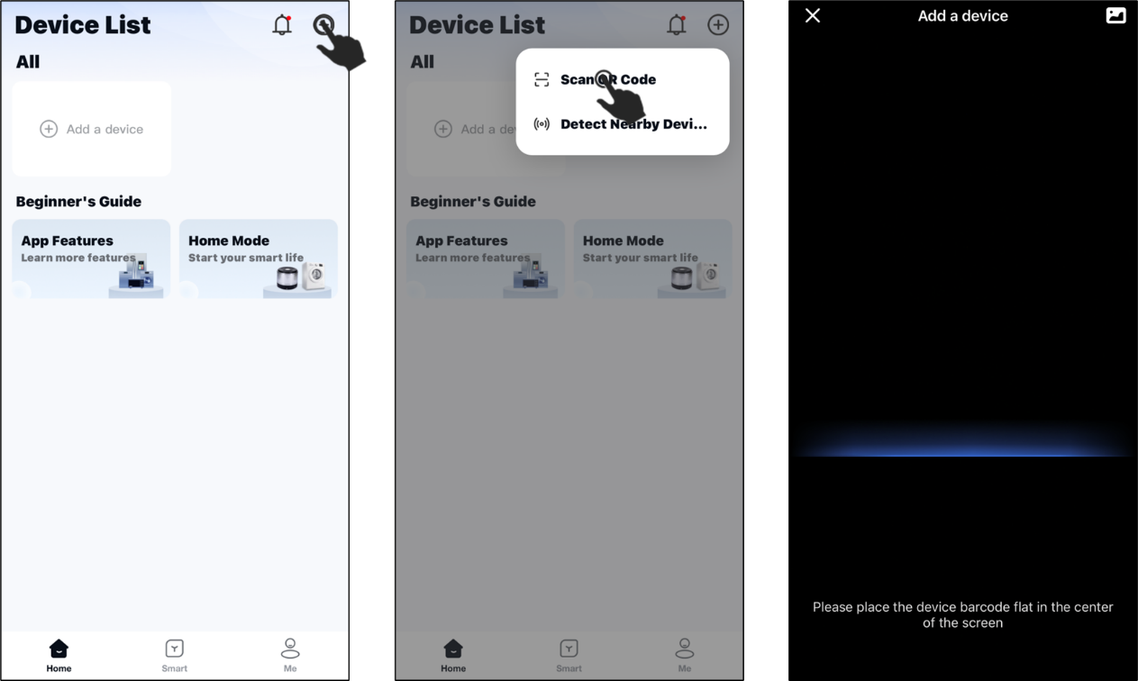

**③** Users can also delete the added device or change the name of the device by this method. Long press on the device icon and click on Rename "" or click on Delete "".

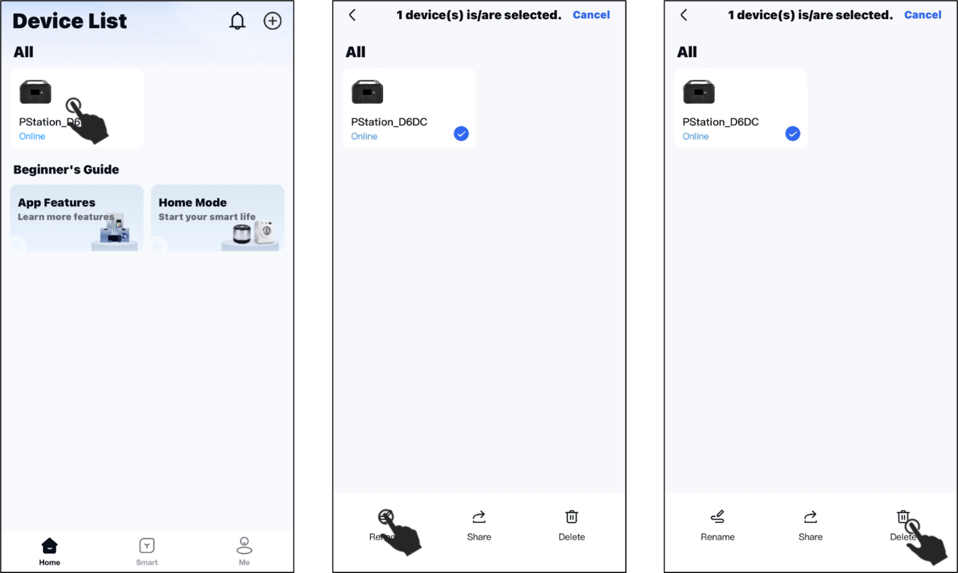

**NOTE:** Read on so that you can use the basic functions of the app properly. If you want to learn more operations, please read the following chapters.

**4 Intelligent Control Device**

**4.1 Scene Setting and Execution**

**①** Click on " **Smart** " at the bottom of the interface, then click on the "" in the top right corner and select " **Create Scene** ".

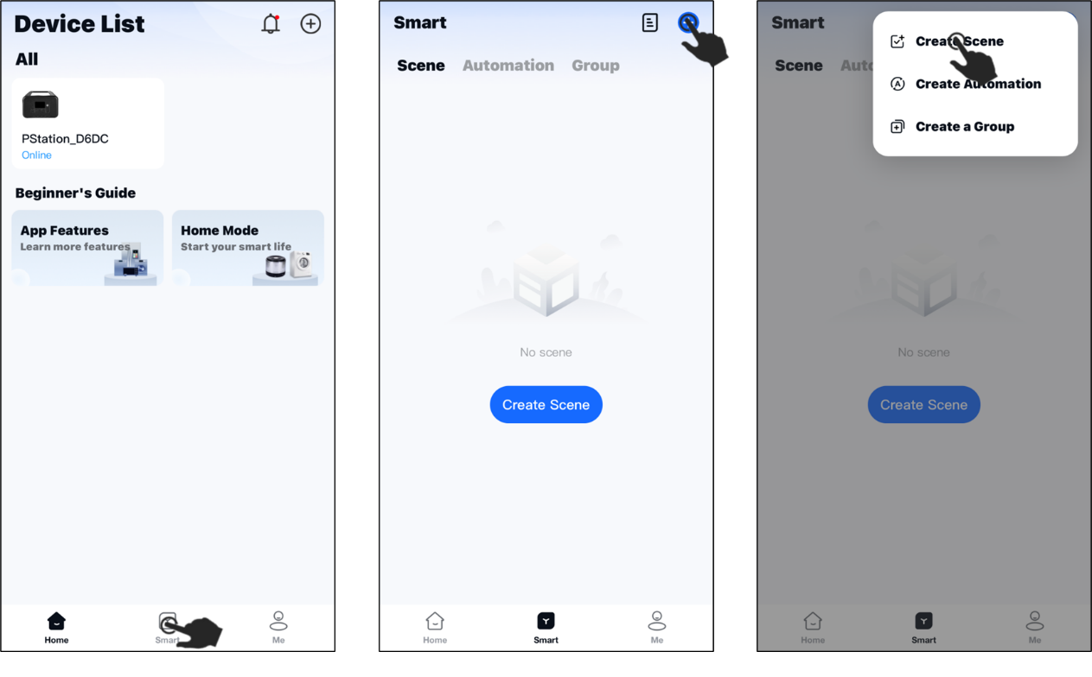

**②** Set the name of the scene, click " **Confirm** "; select the desired icon, click " **Confirm** "; finally click " **Add a device** ".

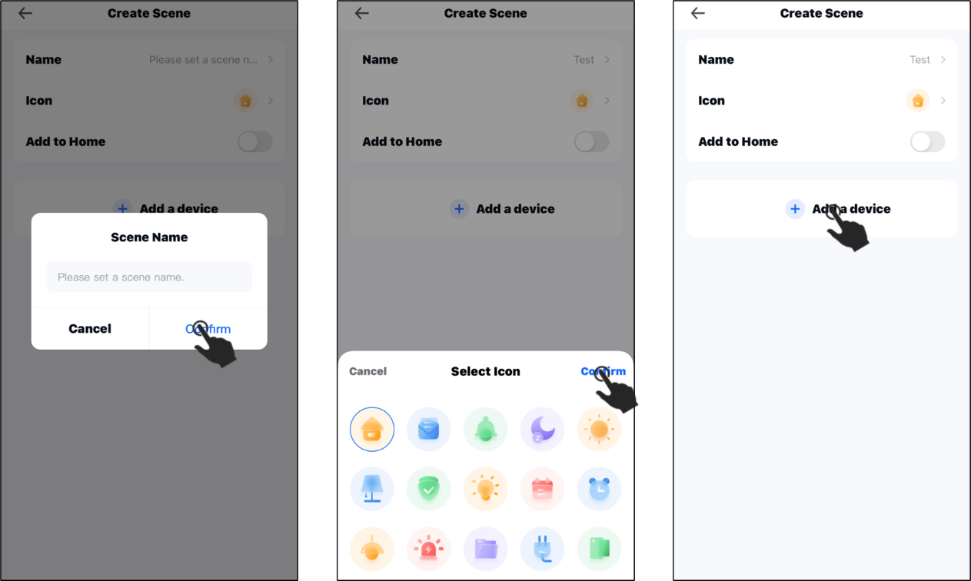

**③** Select the devices that can be added and click on " **Confirm** ".

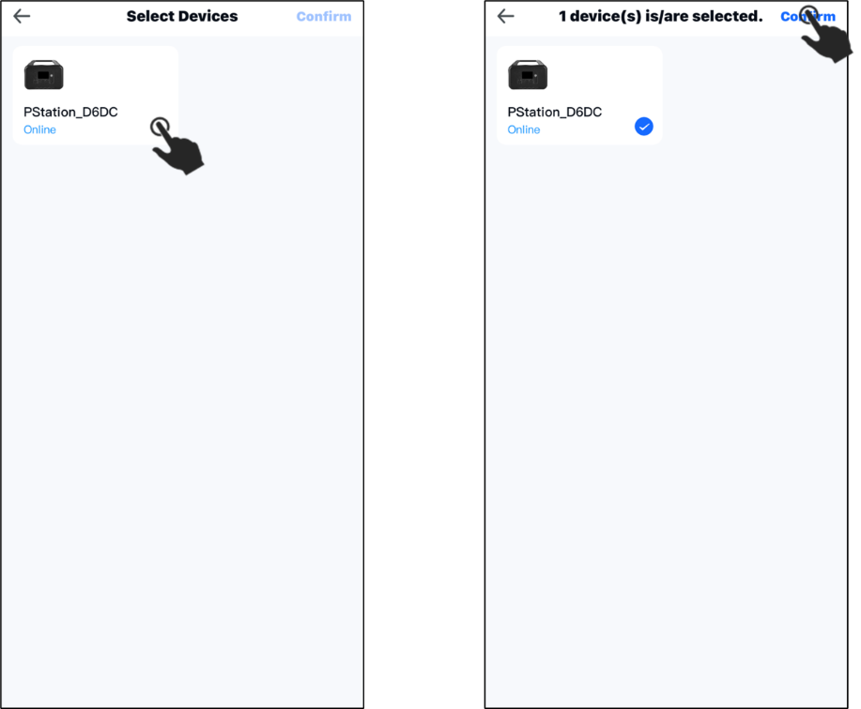

**④** Click on the added device, enter the parameter setting panel, set the required device parameters, click " **Complete** ", and finally click " **Save** ".

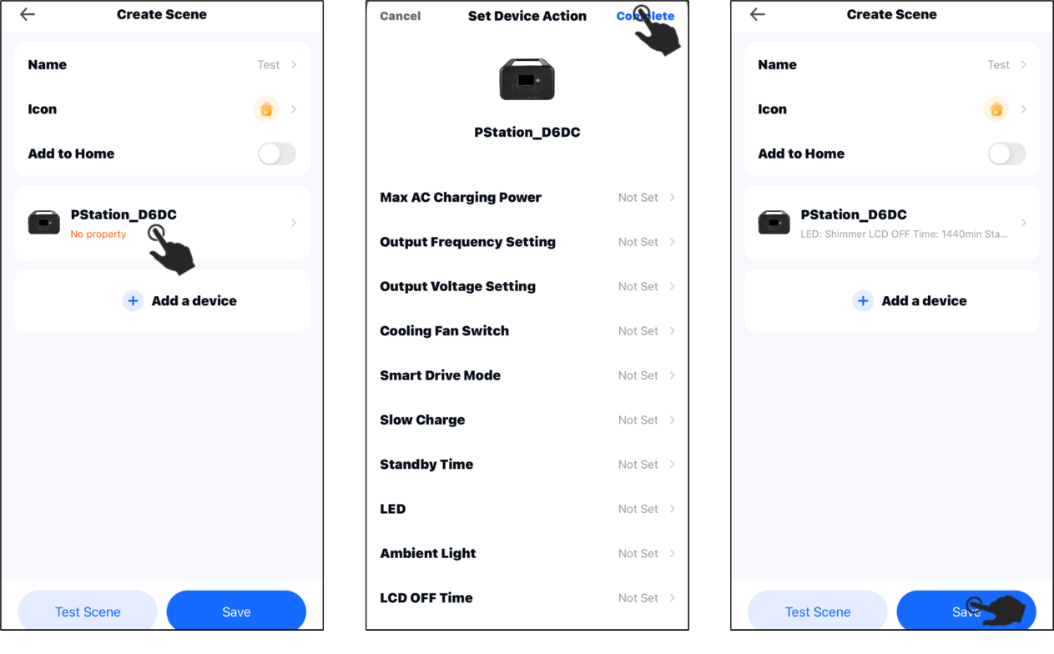

**⑤** Finally, by clicking on the saved scene, the device can execute the parameter scheme set by the scene. 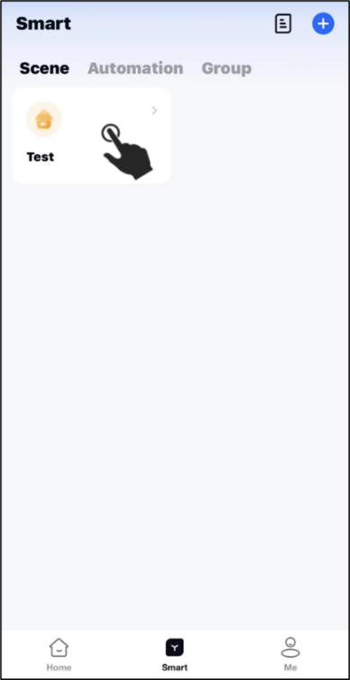

**4.2 Automation Control**

**①** Click on " **Automation** ", then click on the "" in the upper right corner and select " **Create Automation** ".

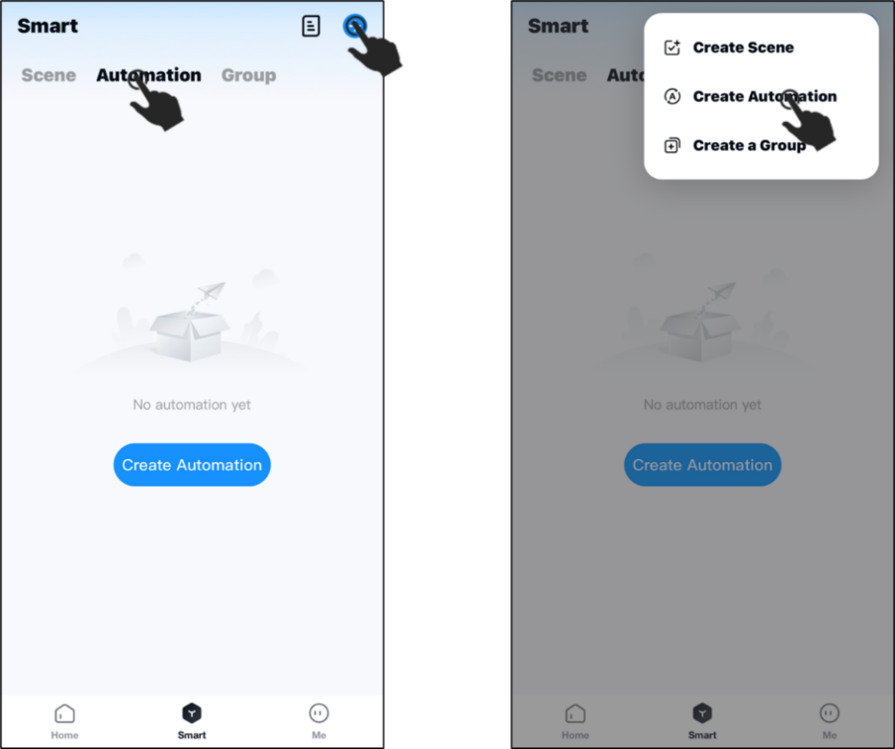

**②** Enter the Create Automation screen, click " **Add Trigger Condition** ", then click " **Timer** " to set the execution time condition, and finally click " **Confirm** ".

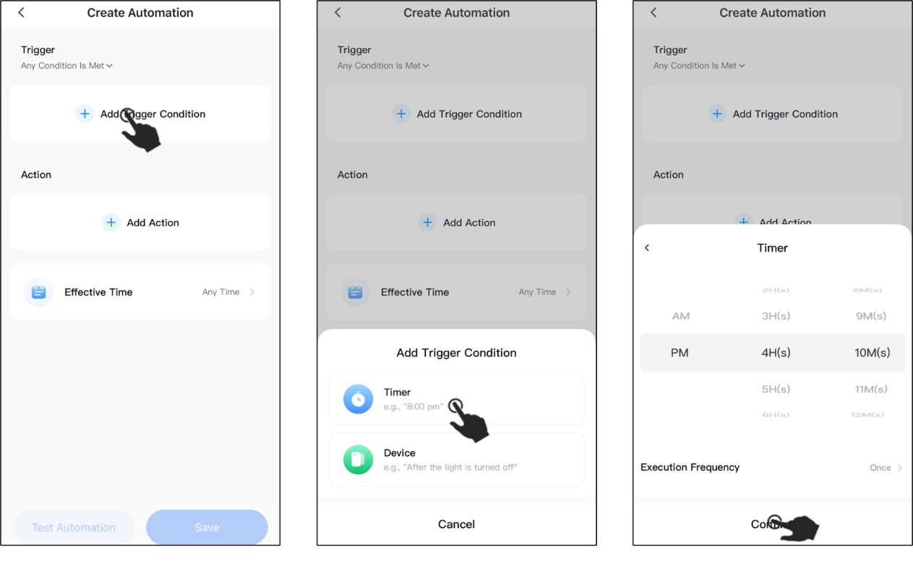

**③** Click " **Add Action** ", then click " **Enable Scene** ", select the created scene, and finally click " **Confirm** ".

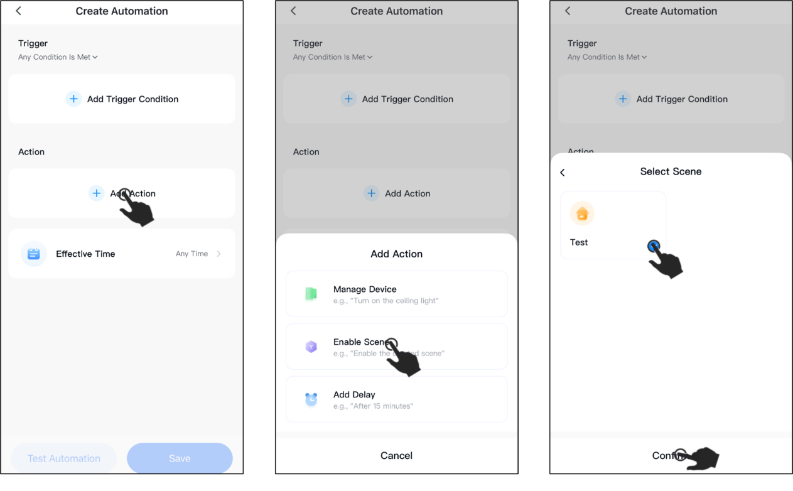

**④** Click on " **Effective Time** " to set the time period for automation and then click on " **Confirm** ".

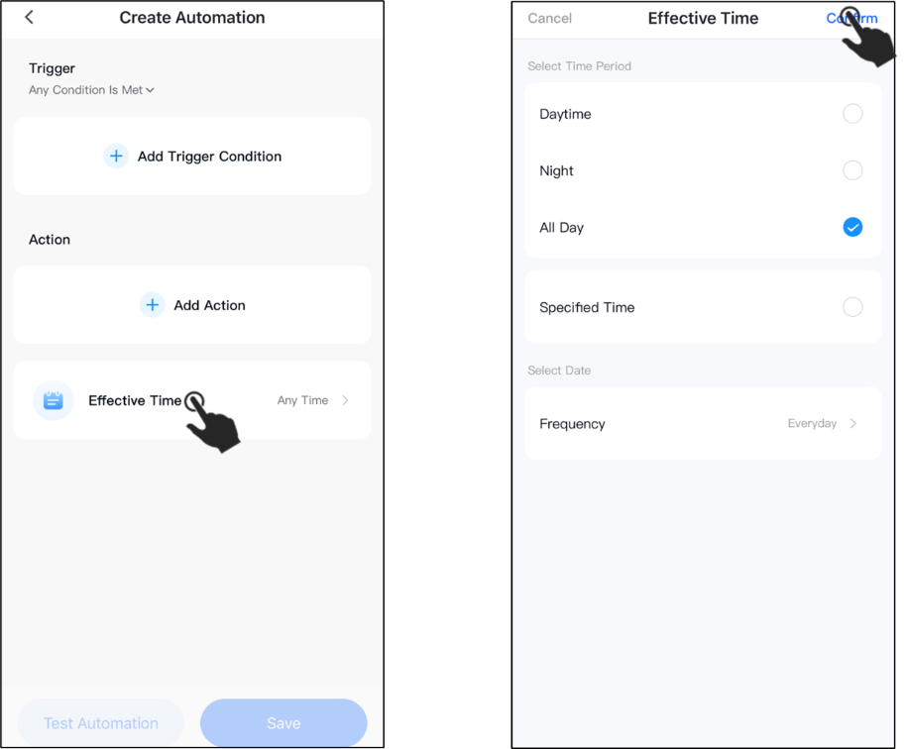

**⑤** Click " **Save** ", enter the name of the automation programme and click

" **Confirm** ". When the time meets the time conditions you set and the time is within the executable time period you set, the device will automatically execute the scene programme you set.

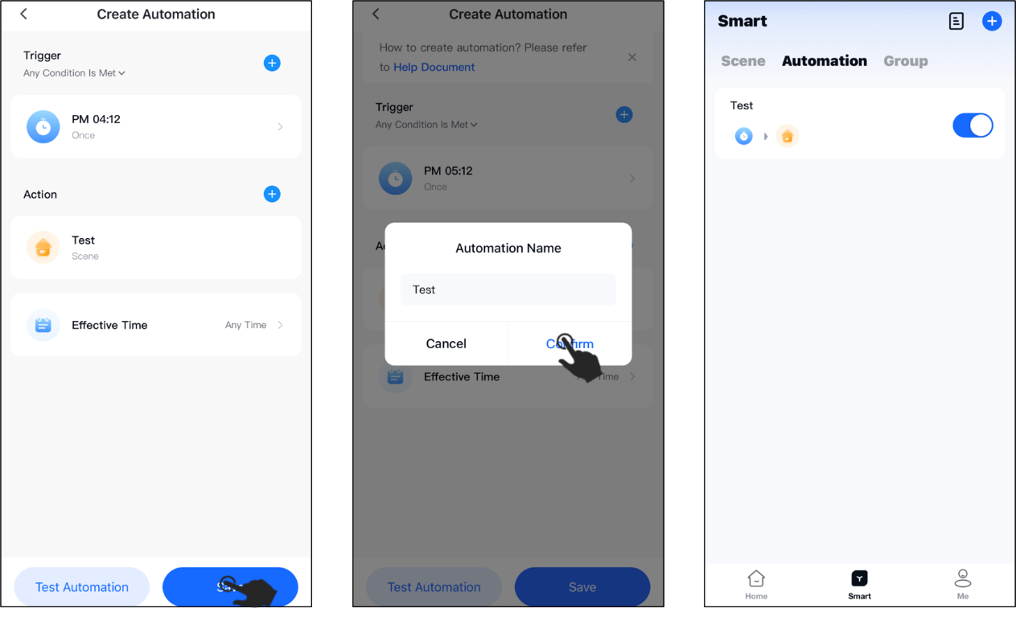

**4.3 Batch Control**

**①** Click on " **Group** ", then click on the "" in the upper right corner and select " **Create a Group** ".

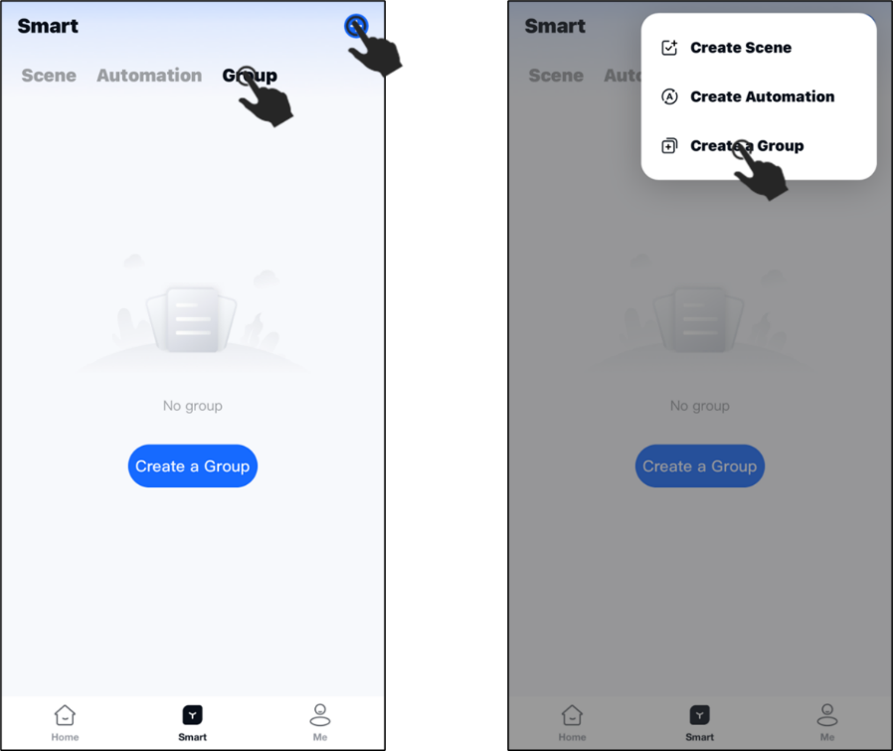

**②** Set the group name and click " **Confirm** ". Click on the group you have created and then click on " **+Add** ".

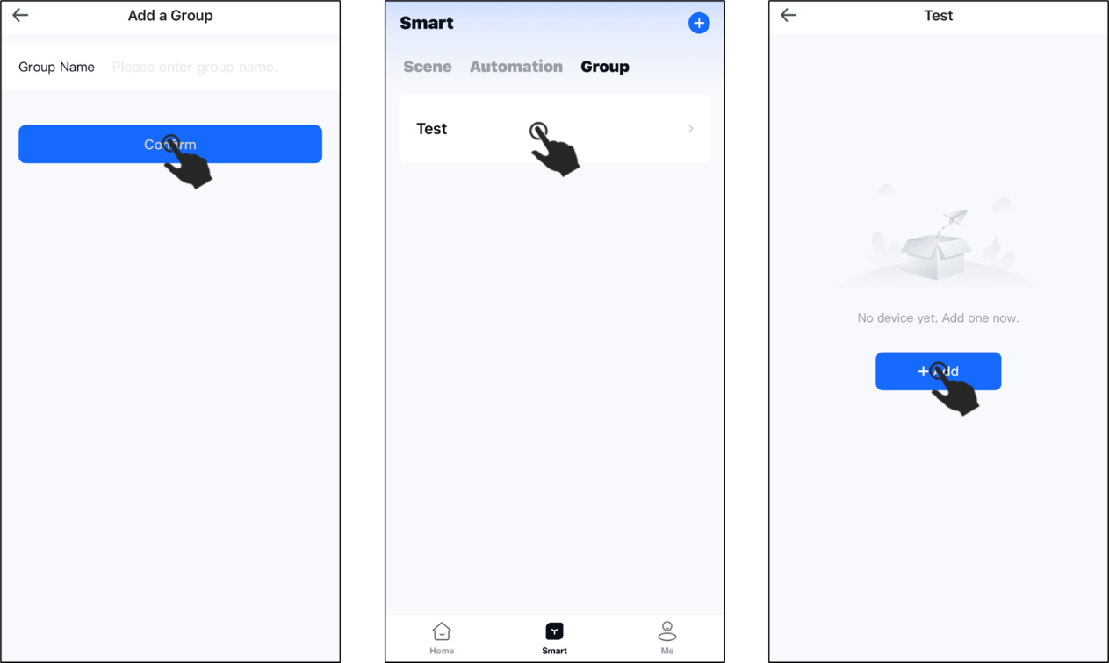

**③** Select addable devices and click " **Add Now** " (multiple devices can be selected) to add the devices to the created group. Click " **Batch Control** ", select the devices you want to control in the group (multiple devices can be selected), and then click " **Control** ".

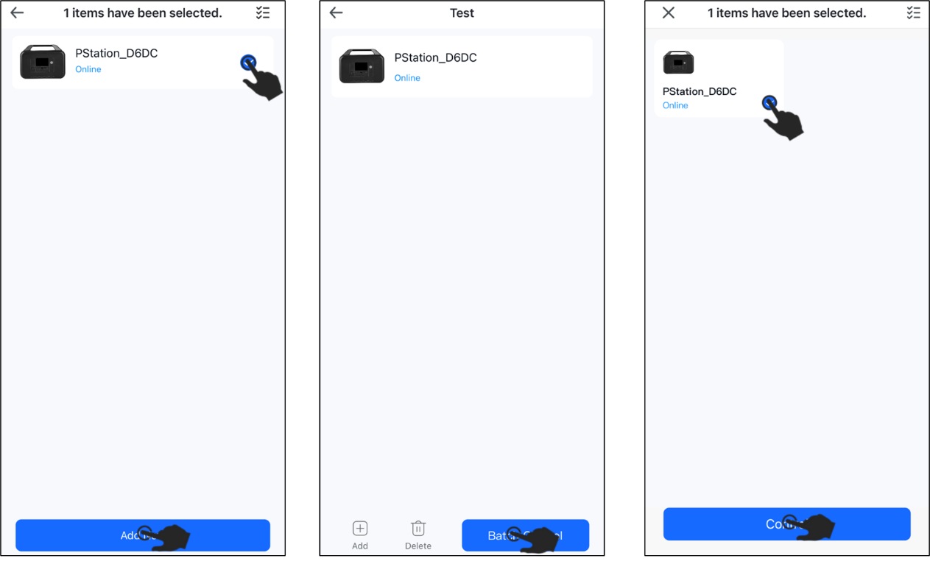

**④** Enter the control command panel, select and set the command, and finally click " **Send Command** " to batch control the device.

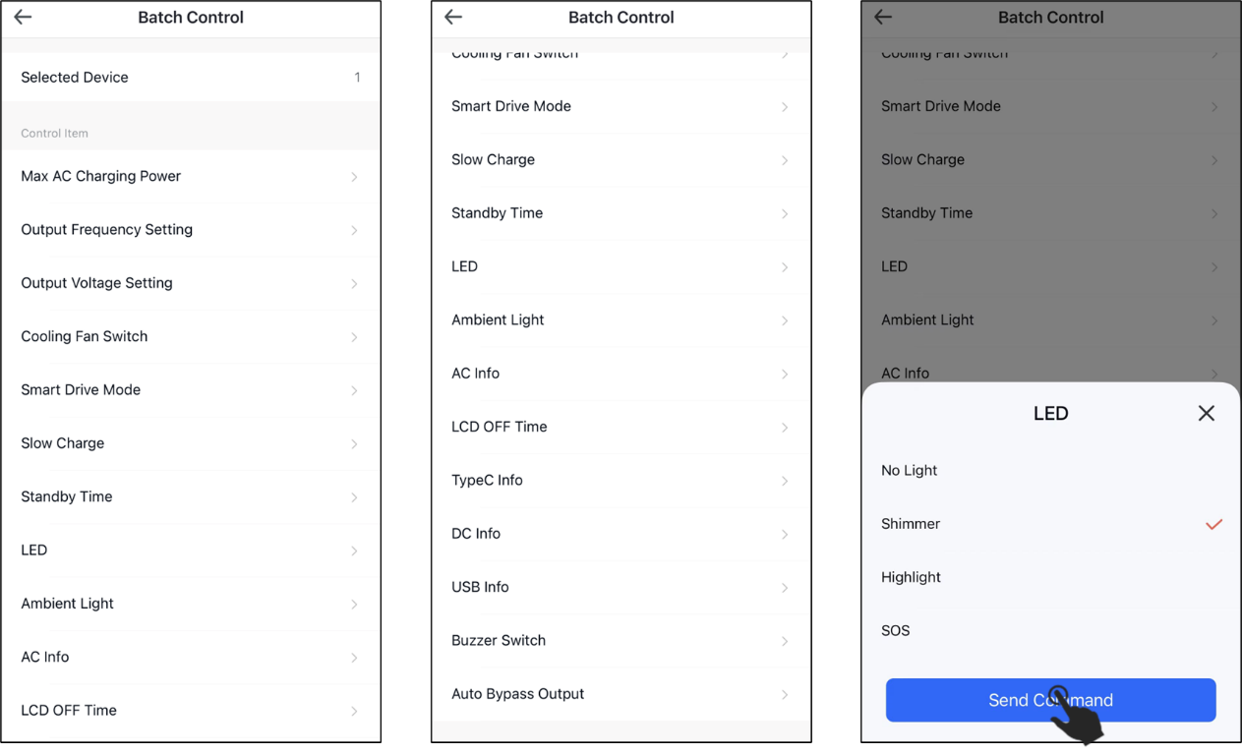

**5 System Setup**

Click "**Me**" at the bottom of the interface to switch to the System Settings and Information interface.

**Setting:**

■ Device Update------Update the latest version of the device

-------------------------------------------------------------------------------------------------------

■ Home Mode------Family members can be invited to use smart devices in the home together.

-------------------------------------------------------------------------------------------------------

■ Push Settings------Enable/disable push notifications, alarms, and fault messages.

-------------------------------------------------------------------------------------------------------

■ Clear Cache------Clear the system cache

-------------------------------------------------------------------------------------------------------

■Privacy Policy Management------Check out the app's privacy policy and service agreement.

-------------------------------------------------------------------------------------------------------

■ System Permission Management------Enable/disable APP access to phone location, camera, photo albums.

**About:**

Check the version of the app

-------------------------------------------------------------------------------------------------------

■Open-source Component License------List of open source component licences.

-------------------------------------------------------------------------------------------------------

■Upload Log------Upload log to report problems encountered during device usage.

-------------------------------------------------------------------------------------------------------

■Write a Review------Rate the App.

**Feedback:**

This is where you can provide feedback on any shortcomings in your experience with the app.

